Portfolio Task 2a: Qualitative Data Exercise – Annotated Image Exemplar

Birds watching

Camera
Binocular
Birds watchers

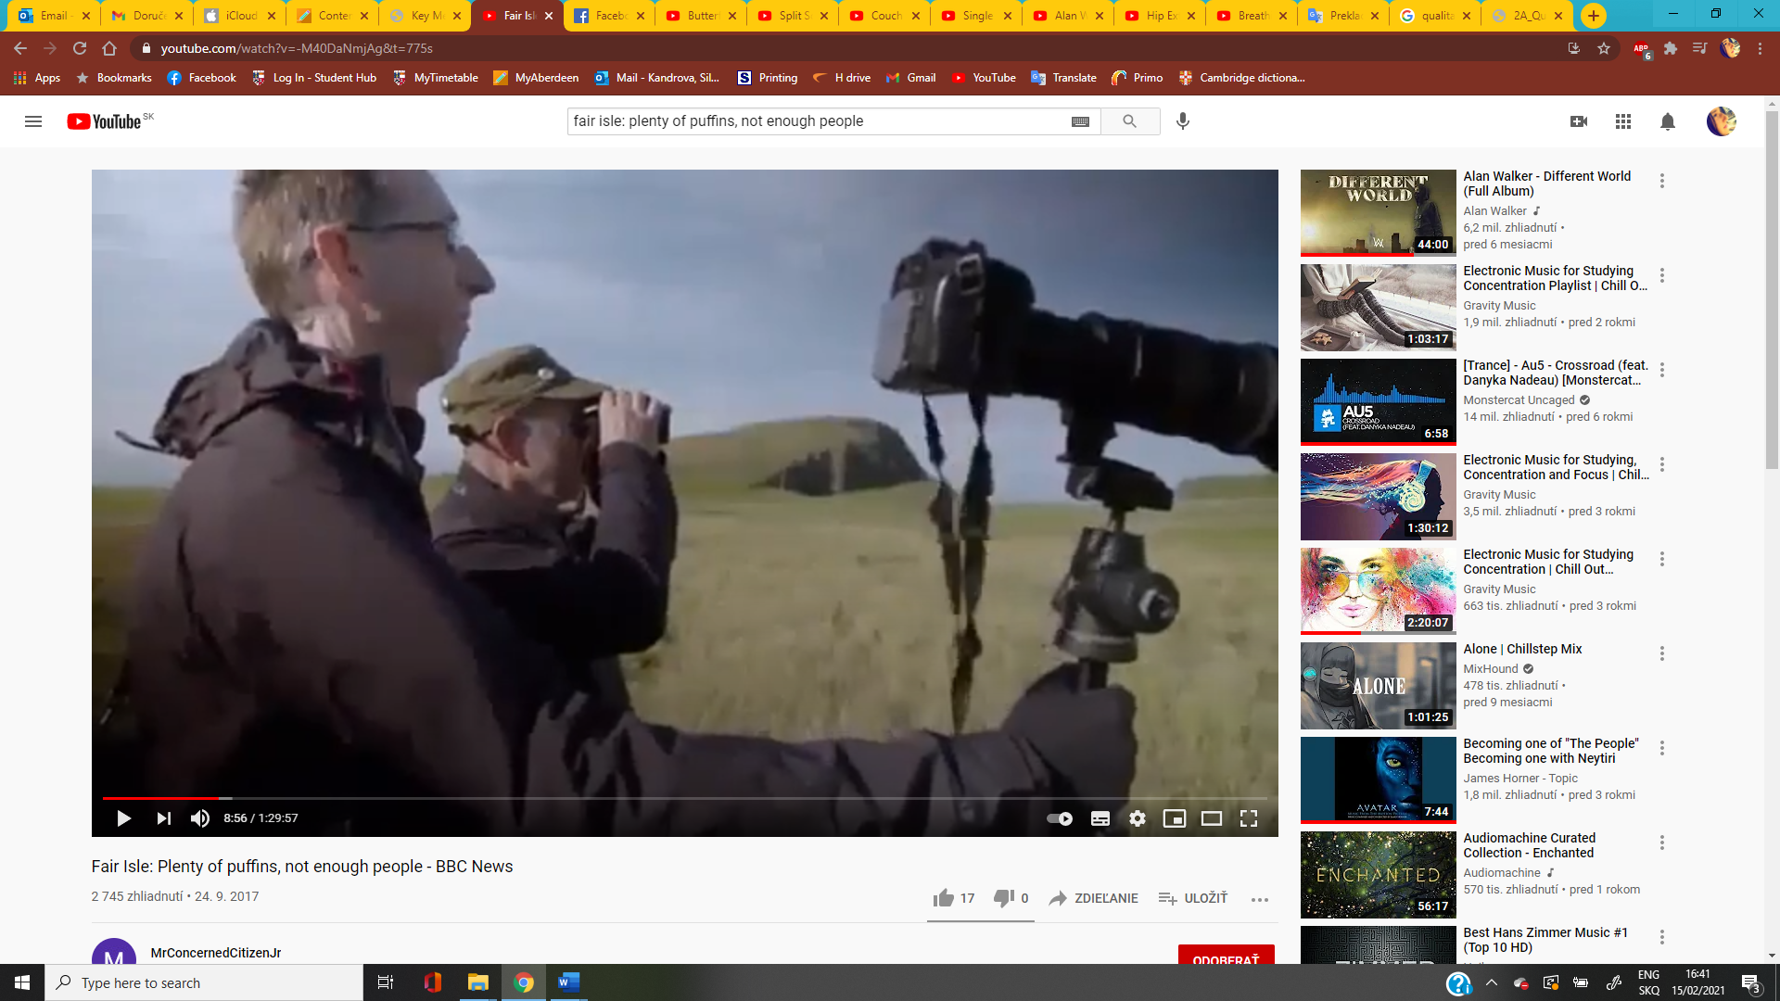
Image from: Fair Isle: Plenty of puffins, not enough people - BBC News, 10.9.2017
Timestamp: 00:08:56
Available at: https://youtu.be/32gas5YYO1g
Annotated by: 51985563
Description: Two men stands near the cliff and observe birds. One man uses binocular in order to see birds in better resolution. The second man with glasses holds tripod with a camera to take some pictures. Based on their clothes, we can assume that it is autumn or spring, with a nice sunny day.

